NAME: ZAINAB AZEEM

ROLL NO: 21P-8025

PROGRAM: BCS

1. Write a function that takes the values of two sides of a right triangle and then

determine the size of the hypotenuse.

CODE

def sizeofhypotunuse(a=1,b=1): #1st code

from math import sqrt

hypo=sqrt((a*a)+(b*b))

return hypo

# finding hypotunuse of triangle using formula and two sides are taken from user

a=int(input("enter value1:"))

b=int(input("enter value2:"))

sizeofhypotunuse(a,b)

OUTPUT

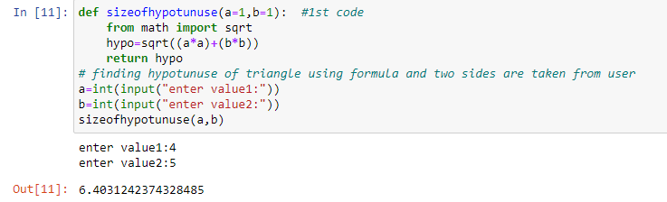

2-Write a program that examines three variables—x, y, and z—and

prints the largest odd number among them. If none of them are odd, it should

print a message to that effect.

def largest_odd():

if x%2==0 and y%2==0 and z%2==0:

print("none of them is odd")

elif x>y and x>z:

if x%2!=0:

print(x,"is the greatest")

elif y%2!=0:

print(y,"is the greatest")

elif z%2!=0:

print(z,"is the greatest")

# if x is the largest odd number print x is greatest among y and z

elif y>x and y>z:

if y%2!=0:

print(y,"is the greatest")

elif x%2!=0:

print(x,"is the greatest")

elif z%2!=0:

print(z,"is the greatest")

# if y is the largest odd number print y is greatest among x and z

elif z>y and z>x:

if z%2!=0:

print(z,"is the greatest")

elif y%2!=0:

print(y,"is the greatest")

elif x%2!=0:

print(x,"is the greatest")

# if z is the largest odd number print z is greatest among x and y

x=int(input("enter x"))

y=int(input("enter y"))

z=int(input("enter z"))

largest_odd()

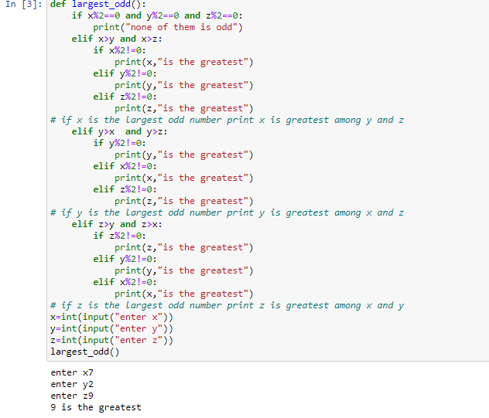

3- Write a program that check whether a year is leap year or not? create a function named

Is Leap has an formal parameter, year, determines whether the year is a leap year, or not and

print the message to that effect. A year is a leap year if it is divisible by 4 but is not divisible

by 100 except when divisible by 400.

CODE

def Leap(year):

if year%400==0 or year%100!=0 and year%4==0:

print(year,"is a leap year")

else:

print (year,"is not a leap year")

# finding whether the year is leap year or not:

year=int(input("Enter year: "))

Leap(year)

Output

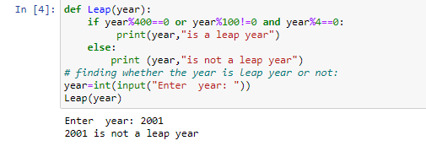

4- Build a GPA calculator that inputs grades of 3 different subjects along with the credit hours

from the user and displays the user’s GPA.

CODE

def result_gpa(GP):

if GP=="A":

return 4.0

elif GP=="A-":

return 3.67

elif GP=="B+":

return 3.33

elif GP=="B":

return 3.0

elif GP=="B-":

return 2.67

elif GP=="C+":

return 2.33

elif GP=="C":

return 2.0

elif GP=="C-":

return 1.67

elif GP=="D+":

return 1.33

elif GP=="D":

return 1.0

elif GP=="F": #finding GPA of a person using conditional statement:

return 0

GP1=str(input("enter grade of subj1:"))

CH1=float(input("enter hours of subj1:"))

GP2=str(input("enter grade of subj2:"))

CH2=float(input("enter hours of subj2:"))

GP3=str(input("enter grade of subj3:"))

CH3=float(input("enter hours of subj3:"))

GPA=((result_gpa(GP1) * CH1) + (result_gpa(GP2) * CH2) + (result_gpa(GP3) * CH3)) / (CH1 + CH2 + CH3)

print(GPA)

